**Unspillabowl**

**Chan Kim**

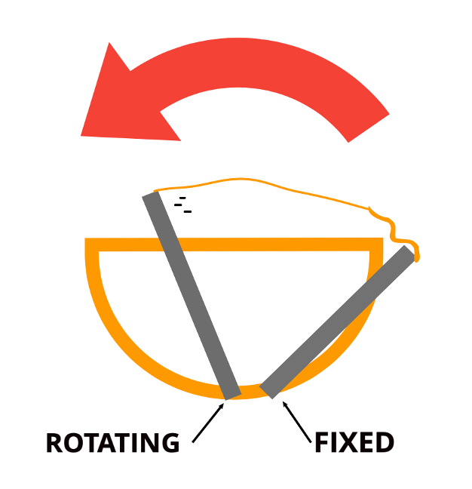

Introduction:

This project is a self-covering bowl to avoid unwanted messes that come from children knocking over their food bowls. When the tilt sensors detect the bowl is spilling, the servos will spring forward, pulling the awning over the top of the bowl, preventing food from falling out. Our target audience is children between 1 ~ 5 years old.

